Report
Of
Social Media Marketing Internship at Satvify

Submitted
To
School of Computer Science and Engineering
IILM University, Greater Noida, U.P.

In partial fulfilment of the requirement of degree of
B.Tech CSE



By
Roll Number of Student: 2410030557
Name of Student: BANDHAN SHARMA
Batch: 2026-27

2026-27

CANDIDATE’S DECLARATION
I, BANDHAN SHARMA, Roll No. 2410030557, do hereby declare that the internship report titled “Social Media Marketing Internship at Satvify” has been completed by me to fulfil the requirement for the award of the degree of Bachelor of Technology in CSE. All the references have been quoted and I have not taken as such any material from any other source. I affirm to you that this report is my own and has not been submitted to any other institute for any degree/diploma requirement and further I shall be solely responsible for any kind of copyright violation in this regard.

Signature
Student Name: BANDHAN SHARMA
Roll No.: 2410030557
ACKNOWLEDGEMENT
I am using this opportunity to express my gratitude to everyone who supported me throughout the Internship Program. I am thankful for their aspiring guidance, invaluably constructive criticism and friendly advice during this work. I am sincerely grateful to them for sharing their truthful and illuminating views on a number of issues related to this work.
I extend my heartfelt thanks to Ms. Yukti Setia, Founder of Satvify, for giving me the opportunity to work as a Social Media Marketing Intern and for trusting me with real responsibilities in the brand’s digital presence. Her guidance, timely feedback and encouragement helped me understand how a brand communicates with its audience through social media.
I am also grateful to the School of Computer Science and Engineering, IILM University, Greater Noida, and to my faculty members for their support and for encouraging students to gain practical industry exposure alongside their academic learning.
I express my gratitude to my parents for their blessings.

Signature
Student Name: BANDHAN SHARMA
Roll No.: 2410030557

INTERNSHIP COMPLETION CERTIFICATE
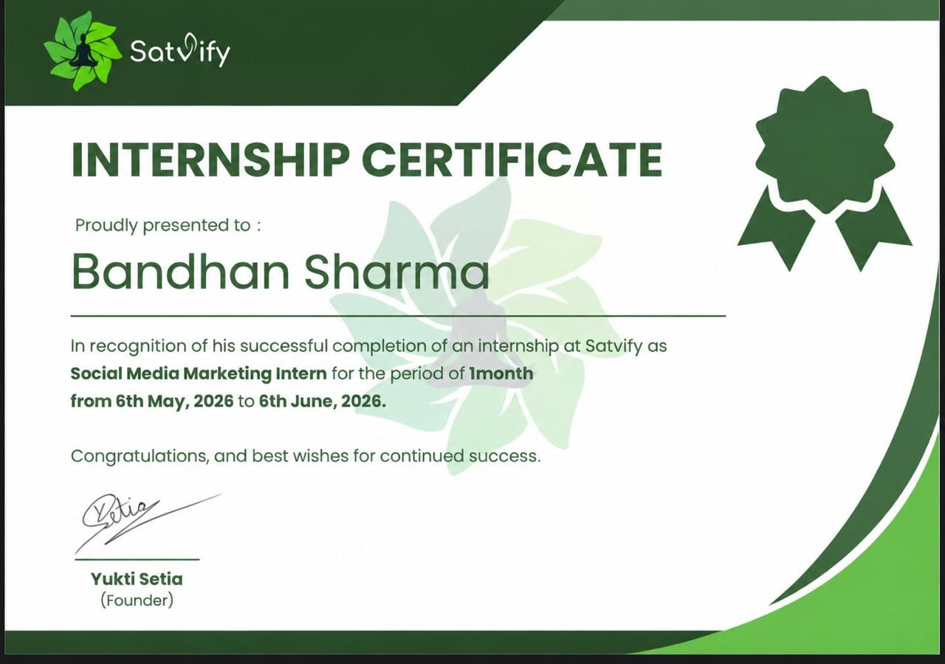
Certificate issued by Satvify to Bandhan Sharma for the period 6th May 2026 to 6th June 2026.

TABLE OF CONTENTS
Chapter No. | Chapter Name | Page Nos.
 | Cover Page | ---
1. | Candidate’s Declaration | i
2. | Acknowledgement | ii
3. | Internship Completion Certificate | ---
4. | Project Description | 1
 | 4.1 Introduction | 1
 | 4.2 Organization Profile | 1
 | 4.3 Problem Statement | 2
 | 4.4 Project Objectives | 2
 | 4.5 Scope of the Project | 3
 | 4.6 Technologies and Tools Used | 3
 | 4.7 System Architecture | 4
 | 4.8 Methodology | 5
 | 4.9 Expected Outcomes | 8
 | 4.10 Certificates of Completion and Communication Proof | 9
5. | Bibliography/References | 10
LIST OF TABLES
Table 4.1 Internship at a glance 2
Table 4.2 Objectives and corresponding activities 3
Table 4.3 Tools and technologies used 4
Table 4.4 Sample content pillars and formats 5
Table 4.5 Key performance indicators tracked 7
Table 4.6 Typical daily and weekly routine of a Social Media Manager 8
Table 4.7 Skills developed during the internship 8
LIST OF FIGURES
Figure 4.1 Social media management system architecture 4
Figure 4.2 Content lifecycle followed during the internship 5
Figure 4.3 Internship completion certificate 9

4. PROJECT DESCRIPTION

4.1 Introduction
Social media has become one of the most important channels through which brands reach, inform and build relationships with people. In India alone, hundreds of millions of people spend a significant part of their day on platforms such as Instagram, Facebook, YouTube, LinkedIn and X. For a young brand, a well-managed social media presence is often the first and most affordable way of being discovered, and the main place where trust is built through consistent communication (Kaplan & Haenlein, 2010).
A Social Media Manager is the professional responsible for this presence. The role goes far beyond posting pictures. It combines strategy, writing, design thinking, community handling, paid promotion and data analysis, all aligned to the goals of the business. The manager decides what the brand should say, to whom, on which platform, in what format and at what time, and then measures whether the effort produced results.
This report documents my one-month internship as a Social Media Marketing Intern at Satvify, carried out from 6th May 2026 to 6th June 2026. During this period I was exposed to the complete workflow of managing a brand’s social media, from research and planning to content creation, publishing, engagement and performance reporting. The report also describes, in detail, the full range of tasks that a Social Media Manager performs, so that it serves both as a record of my experience and as a reference on the profession.

4.2 Organization Profile
Satvify is a wellness-oriented brand whose identity, a meditating figure surrounded by green leaves, reflects the values of balance, mindfulness and healthy living. The organization is led by its Founder, Ms. Yukti Setia, who issued the internship certificate. As a growing brand, Satvify relies strongly on digital platforms to introduce its message, share useful content and stay in regular contact with its community.
The social media function at Satvify supports three broad business needs: building brand awareness among new audiences, educating followers through valuable and relatable content, and guiding interested people towards the brand’s offerings. Working in such a team allowed me to see how a small and agile organization makes decisions quickly and how each piece of content is tied to a purpose.
Table 4.1: Internship at a glance
Particular | Details
Organization | Satvify
Designation | Social Media Marketing Intern
Duration | 1 month (6th May 2026 to 6th June 2026)
Certificate issued by | Ms. Yukti Setia, Founder
Mode of work | Remote / project-based (as assigned)
Domain | Social media marketing and digital branding

4.3 Problem Statement
Many small and emerging brands have good products and genuine ideas but struggle to turn them into visible, consistent and engaging online communication. Typical problems include irregular posting, content that does not match audience interests, unclear brand voice, low reach, comments and messages that go unanswered for days, and decisions taken on assumption instead of data.
The problem addressed during this internship was therefore: how can a brand plan, create, publish and evaluate social media content in a structured manner so that its visibility, engagement and community trust grow steadily? Solving this requires a repeatable process rather than occasional posting, and an understanding of every task involved in managing a social media presence professionally.

4.4 Project Objectives
The objectives of the internship were set to cover both the learning goals of the student and the practical needs of the organization:
- To understand the role, responsibilities and day-to-day workflow of a Social Media Manager.
- To research the target audience, competitors and trends relevant to a wellness brand.
- To plan content through content pillars and a structured content calendar.
- To create platform-appropriate posts, captions, graphics and short videos.
- To publish and schedule content at suitable times using hashtags and keywords.
- To handle community engagement, replies and brand reputation professionally.
- To track performance metrics and convert them into practical recommendations.
Table 4.2: Objectives and corresponding activities
Objective area | Activities carried out
Research | Audience study, competitor review, trend and hashtag research
Planning | Content pillars, weekly and monthly calendars, content briefs
Creation | Caption writing, graphic design, reel/short-video ideas and editing
Publishing | Scheduling, platform formatting, hashtag and keyword placement
Engagement | Replying to comments and messages, community interaction
Analysis | Insights review, KPI tracking, summary reports and suggestions

4.5 Scope of the Project
The scope of this internship covered the organic (non-paid) management of the brand’s social media handles, along with exposure to the basics of paid promotion. Within this scope, the work included audience and competitor research, content ideation, calendar planning, content creation, scheduling, engagement management and monthly performance review across the platforms used by the brand.
The internship did not cover areas that belong to other functions of the organization, such as product development, pricing, logistics or website development. Paid campaign budgets and final brand decisions remained with the management; as an intern my role was to assist, suggest and execute under guidance. The knowledge described in this report is, however, applicable to any organization that wants to build a professional social media presence.

4.6 Technologies and Tools Used
Modern social media management depends on a combination of native platform tools and third-party applications. The tools below are the ones commonly used in this role and form the toolkit I worked with or studied during the internship.
Table 4.3: Tools and technologies used
Category | Tools | Purpose
Social platforms | Instagram, Facebook, LinkedIn, YouTube, X | Publishing and community interaction
Design | Canva, Adobe Express | Posts, carousels, stories, thumbnails
Video editing | CapCut, InShot, Instagram editor | Reels, shorts and story videos
Scheduling | Meta Business Suite, Buffer, Hootsuite | Planning and automated publishing
Analytics | Platform Insights, Google Analytics | Reach, engagement and traffic tracking
Planning | Google Sheets, Google Docs, Notion | Calendars, briefs, reports
Research | Google Trends, hashtag and keyword tools | Trends, topics and competitor study
Communication | WhatsApp, e-mail, Google Meet | Coordination and approvals

Alongside these tools, the role needs non-technical skills such as writing, creativity, time management, empathy and the ability to adapt quickly to platform changes.

4.7 System Architecture
Social media management can be viewed as a system of connected layers. At the top are the brand’s goals, audience and strategy. These feed the planning, creation and publishing stages. The published content then reaches the platforms and generates responses, which are handled in the engagement layer. Analytics collects data from both layers and returns insights to the strategy, so that the system continuously improves. Figure 4.1 shows this structure.
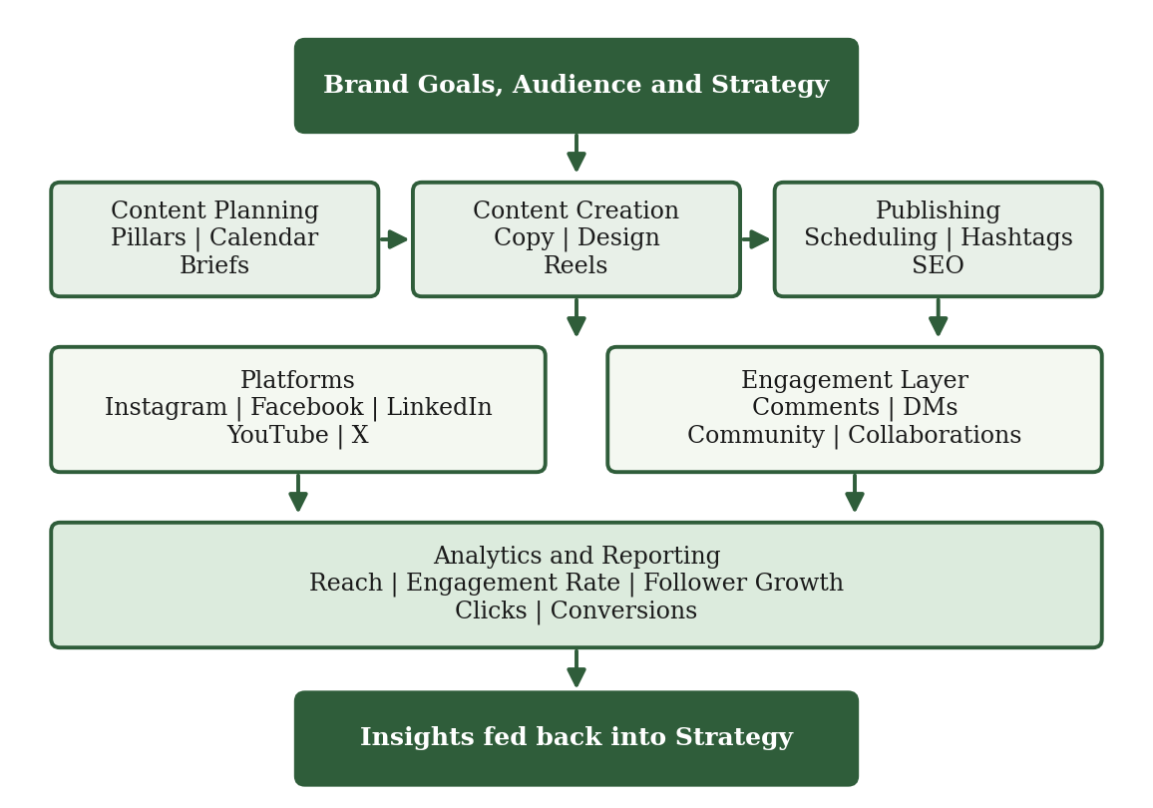
Figure 4.1: Social media management system architecture

4.8 Methodology
The internship followed a seven-step content lifecycle, shown in Figure 4.2. Every piece of content, whether a single story or a month-long campaign, passes through these stages. The detailed work performed at each stage, which together describe what a Social Media Manager does, is explained below.
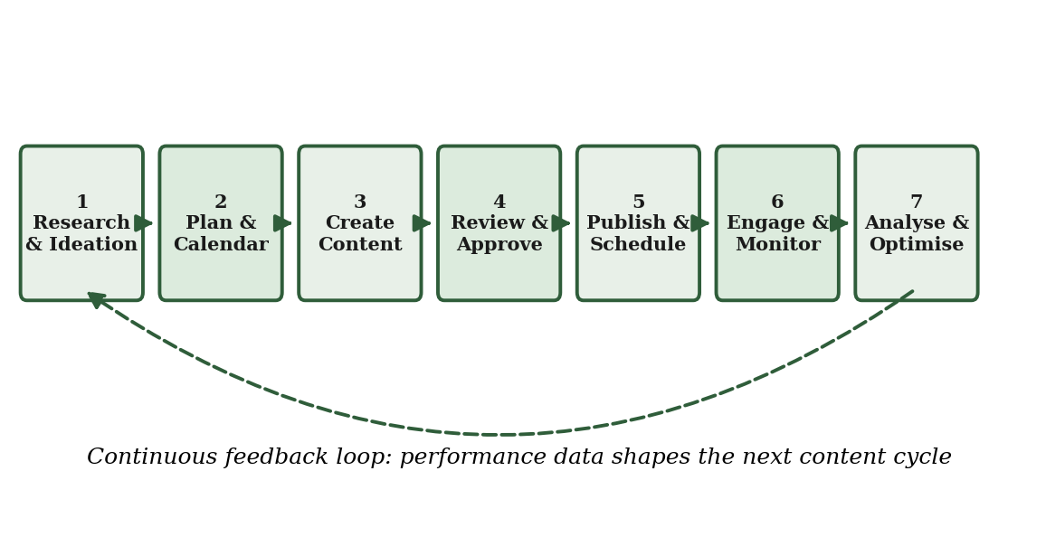
Figure 4.2: Content lifecycle followed during the internship
4.8.1 Strategy, research and goal setting
The work begins with clear goals such as awareness, followers, website visits, leads or sales. The manager defines the target audience through age, interests, location and online behaviour, and studies competitors to learn what content they post, how often, and what receives engagement. Brand voice, tone and visual style are documented so that every post feels consistent. Trend research on Google Trends and the platforms themselves helps identify topics the audience is already interested in.
4.8.2 Content planning and calendar
Content is organised under a few content pillars, which keep the feed balanced and purposeful. A monthly content calendar, prepared in a spreadsheet, lists the date, platform, format, topic, caption status, design status and approval status of each post. Festivals, awareness days and brand events are marked in advance. Each post also has a short content brief explaining its purpose, key message and call to action.
Table 4.4: Sample content pillars and formats
Content pillar | Example topics | Formats
Educational | Wellness tips, how-to guides, myth-busting | Carousels, reels
Inspirational | Quotes, mindful-living ideas, stories | Static posts, stories
Brand and product | Offerings, behind-the-scenes, launches | Reels, photos, stories
Community | User content, polls, Q&A, testimonials | Stories, polls, reposts
Promotional | Offers, announcements, events | Posts, ads, stories

4.8.3 Content creation
Content creation includes writing captions with a strong hook, a useful body and a clear call to action; designing graphics, carousels and story templates in the brand’s colours; and planning and editing short videos. The manager follows each platform’s best practices: vertical video for reels and shorts, a professional tone for LinkedIn, and visual storytelling for Instagram. Accessibility is also considered through readable fonts, good contrast and alt text. All copy is proof-read, and copyright of images, music and fonts is respected.
4.8.4 Review, publishing and scheduling
Content is shared with the founder or senior team for approval before publishing. Approved posts are scheduled using tools such as Meta Business Suite at the times when the audience is most active, based on insights data. Hashtags, location tags, keywords in captions and profile optimisation (bio, links, highlights, profile photo) improve discoverability. Consistency in the posting frequency is maintained so that the algorithm and the audience both learn to expect the brand’s content.
4.8.5 Community management and engagement
Social media is two-way communication. The manager monitors comments, direct messages and mentions, replies promptly and politely, answers questions, thanks supporters and gently handles criticism. Stories with polls, quizzes and question stickers are used to start conversations. Engaging with relevant accounts and sharing user-generated content makes followers feel valued and gradually builds a loyal community.
4.8.6 Influencer, collaboration and partnership support
Many brands grow through collaborations. The manager identifies creators whose audience and values match the brand, prepares outreach messages, shares briefs, tracks deliverables and measures the outcome of each collaboration. Giveaways, co-created posts and takeovers are also coordinated, along with proper disclosure of paid or gifted partnerships.
4.8.7 Paid social media advertising
Alongside organic work, a social media manager often supports paid campaigns. This involves selecting an objective (awareness, traffic or conversions), defining audiences by location and interests, preparing creatives and copy, setting a budget and schedule, and A/B testing different versions. The results are monitored through cost per click, cost per result and reach, and budgets are shifted towards the best-performing ads.
4.8.8 Trend monitoring and social listening
Platforms change fast. The manager follows new features, audio trends, formats and algorithm updates and decides which are suitable for the brand. Social listening, that is, tracking brand mentions, relevant keywords and conversations, helps understand how people feel about the brand and uncovers new content ideas.
4.8.9 Reputation and crisis management
A negative comment, a misunderstanding or a viral complaint can affect a brand quickly. The manager responds calmly, acknowledges the concern, moves detailed discussions to private channels and escalates serious issues to management. A simple response guideline and approved tone prevent hasty or emotional replies and protect the brand’s credibility.
4.8.10 Analytics and reporting
Performance is reviewed weekly and monthly. Reach, impressions, engagement rate, follower growth, saves, shares, video views, link clicks and conversions are tracked and compared with earlier periods. The findings are summarised in a short report that states what worked, what did not and what will change next month. Table 4.5 lists the main indicators.
Table 4.5: Key performance indicators tracked
Metric | Meaning | Why it matters
Reach | Unique accounts that saw the content | Measures visibility
Impressions | Total number of times content was shown | Shows content frequency
Engagement rate | Likes, comments, shares and saves per reach | Shows content quality
Follower growth | Net new followers over a period | Shows audience building
Click-through rate | Link clicks divided by impressions | Shows interest in action
Conversions | Sign-ups, enquiries or purchases | Shows business impact

4.8.11 Documentation, coordination and professional ethics
Finally, the manager maintains organised folders of creatives, passwords and access in a secure manner, keeps the content calendar updated and coordinates with designers, photographers and management. Ethical practice, including honest claims, respect for privacy, data protection, copyright, fair disclosure and sensitivity to the audience, is important, especially for a wellness brand where health-related statements must be responsible and accurate.
To bring all of these responsibilities together, the work of a Social Media Manager follows a rhythm of daily, weekly and monthly tasks, summarised in Table 4.6. This routine is what keeps the brand’s presence regular and organised, and it is the pattern I followed during my internship under guidance.
Table 4.6: Typical daily and weekly routine of a Social Media Manager
Frequency | Key tasks
Daily | Check notifications, reply to comments and messages, publish or schedule the day’s post and stories, monitor trends and mentions
Weekly | Finalise next week’s captions and designs, get approvals, review weekly insights, engage with relevant accounts, plan stories and polls
Fortnightly | Review hashtag and keyword performance, update the content bank, coordinate collaborations and creators
Monthly | Prepare the next month’s calendar, compile the performance report, compare against goals, suggest changes in strategy
Quarterly | Audit profiles and competitors, refresh brand visuals and bio, set new goals and test new formats

4.9 Expected Outcomes
The internship was expected to deliver outcomes for both the learner and the organization. For the organization, the expected outcomes were more consistent posting, better-organised content planning, improved responsiveness to the community and a clearer understanding of what content its audience prefers. For me, the expected outcome was practical readiness to work in a digital marketing role.
The outcomes can be summarised in the skills developed during the internship, as listed in Table 4.7.
Table 4.7: Skills developed during the internship
Skill area | What I learned
Strategic thinking | Linking every post to a goal, audience and platform
Content writing | Writing hooks, captions and calls to action in the brand voice
Visual design | Creating consistent graphics and short videos with simple tools
Planning | Preparing content calendars and meeting deadlines
Communication | Engaging with audiences and coordinating with the team
Analytical skills | Reading insights and turning data into decisions
Professionalism | Taking feedback, maintaining ethics and managing time

Challenges faced and lessons learned
No real work is free of challenges, and the internship was no exception. The first challenge was learning to write in a brand voice instead of a personal voice: a caption has to be short, warm and purposeful, and it must match what the brand stands for. The second was working within deadlines, since a content calendar leaves little room for delay once posts are scheduled. The third was understanding the metrics, because high likes do not always mean high reach or real interest. Each challenge taught a practical lesson:
- Consistency. A steady posting rhythm builds more trust than occasional brilliance.
- Clarity. Build every post around one clear message and one clear action for the reader.
- Data. Decide on the basis of insights, not personal preference.
- Responsiveness. Prompt, kind and honest replies to followers matter as much as the posts.
Overall, the internship showed me that effective social media management is a mix of creativity and discipline. It also strengthened my belief that technical students can add real value to marketing roles by bringing an analytical, tool-oriented mindset to creative work.

4.10 Certificates of Completion and Other Communication Proof
The Internship Completion Certificate issued by Satvify, signed by the Founder Ms. Yukti Setia, confirms that I completed the internship as a Social Media Marketing Intern from 6th May 2026 to 6th June 2026. A copy is attached in Chapter 3 of this report and reproduced below for reference.
Figure 4.3: Internship completion certificate
Communication proof: a printout or screenshot of the e-mail or message exchanged with the organization regarding the internship (offer, joining or completion) is to be attached here as an annexure, as required by the report format.

5. BIBLIOGRAPHY / REFERENCES
[1] Chaffey, D., & Ellis-Chadwick, F. (2019). Digital marketing: Strategy, implementation and practice (7th ed.). Pearson Education.
[2] Kaplan, A. M., & Haenlein, M. (2010). Users of the world, unite! The challenges and opportunities of social media. Business Horizons, 53(1), 59–68.
[3] Kotler, P., Kartajaya, H., & Setiawan, I. (2017). Marketing 4.0: Moving from traditional to digital. Wiley.
[4] Tuten, T. L., & Solomon, M. R. (2017). Social media marketing (3rd ed.). SAGE Publications.
[5] Meta. (n.d.). Meta Business Help Centre. https://www.facebook.com/business/help
[6] Google. (n.d.). Analytics Help. https://support.google.com/analytics
[7] HubSpot. (n.d.). HubSpot Academy: Social media marketing courses. https://academy.hubspot.com
[8] Canva. (n.d.). Canva Design School. https://www.canva.com/designschool
Note: Online resources were referred to during October 2026.

